562B
JERZEES

Youth Crewneck Sweatshirt

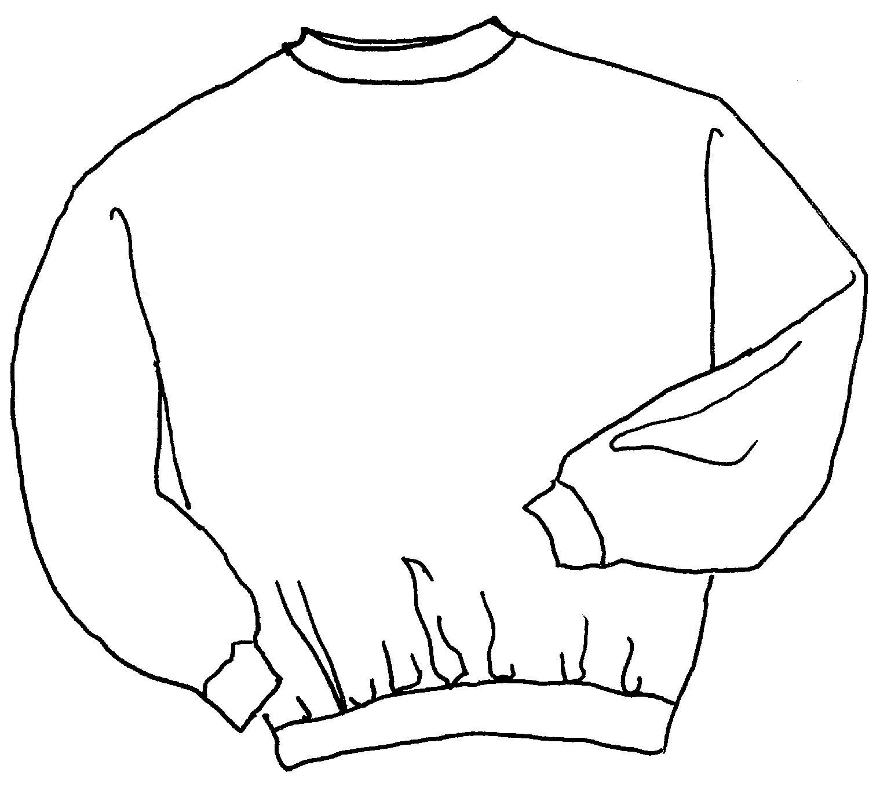

Descriptions
*50/50 Cotton poly, 8 ounce NuBlend fleece
*Ribbed collar, cuffs & waistband with Spandex
*Coverseamed neck and armholes
*Set in sleeves
*Embroidery or screenprinting okay

Finished Garment Measurements

Size | S | M | L
Width | 15 | 17 | 19
Length | 18 | 21 | 24

